Epsom & Ewell
14
v
Bedfont & Feltham
Saturday, 8th December 2018 – 3.00 p.m.
Good afternoon! We welcome the players, supporters and officials of high flying Bedfont & Feltham to High Road for an important League match. Our opponents opened up the season with an 11-0 victory over Bagshot and have never really looked back, currently looking like favourites to earn the guaranteed promotion spot this season.

We have of course met both Bedfont and on many occasions Feltham too, but have met just twice since the new club was formed. We won the first of those matches famously by nine goals to two, which would have been incredible enough before you remember that we actually trailed 2-0 at the half! Then we won the return match 4-1 as our opponents went down from the Premier Division. Now of course we have joined them in Division One and it has to be said that we really need a win today to close the gap on them and indeed the clubs around them.

We were last here seven days ago when we hosted Godalming Town and to say it was an unusual match doesn’t really tell the story as we fought back from conceding two early goals to win with a shot from Scott Murphy that was originally assumed by the officials to have hit the post when it actually hit the stanchion within the goal and came back out!

We have no match next Saturday before journeying to Woking F.C. seven days later for our return League match with Sheerwater. We will then be back at home after Christmas on Saturday 29th December when Eversley & California make their first visit to High Road.

We have plenty to look forward to in 2019 with participation in three cups, and are not out of the promotion race in the League yet, while we are hoping to hear some good news shortly on a new ground. We also have many matches and players available for sponsorship, just ask a Committee member for details.

Further to the accident which befell our Chairman’s wife Maggie, Pete advises the following: "Maggie sends her grateful thanks for everyone's best wishes for a speedy recovery after her broken hip. By the time you read this she hopes to be home and getting more mobile there."

All that remains to be said today is that the club wishes all of its supporters, players and Management a Happy Christmas!

Enjoy the game!

Rich

You can follow us on Facebook: www.facebook.com/epsomandewellfc
Twitter: @EEFCOfficial Instagram at: www.instagram.com/epsomandewellfc
and Youtube at: www.youtube.com/channel/UCtLrpS0x5OaYUACRT34_zng

Cover photo by Gemma Jarman

Bobby Bennett scores our equaliser against Godalming Town last Saturday

Cherry Red Records Combined Counties League
Division One Table 2018/19
inc Tuesday 4th December 2018 | P | W | D | L | F | A | Pts | GD | H | A
Frimley Green | 18 | 11 | 5 | 2 | 35 | 23 | 38 | +12 | 3-0 | 23/2
Bedfont & Feltham | 15 | 11 | 3 | 1 | 53 | 13 | 36 | +40 | 8/12 | 13/4
Epsom & Ewell | 18 | 11 | 1 | 6 | 43 | 29 | 34 | +14 | X | X
Sheerwater | 16 | 10 | 3 | 3 | 37 | 23 | 33 | +14 | 2-3 | 22/12
Farnham Town | 15 | 9 | 4 | 2 | 33 | 13 | 31 | +20 | 2/2 | 1-4
Sandhurst Town | 16 | 9 | 3 | 4 | 27 | 27 | 30 | 0 | 20/4 | 2-0
Dorking Wanderers Res | 19 | 9 | 3 | 7 | 46 | 39 | 30 | +7 | 3-0 | 3-5
Tooting Bec | 16 | 9 | 2 | 5 | 32 | 22 | 29 | +10 | 3-1 | 30/3
Ash United | 17 | 7 | 4 | 6 | 44 | 38 | 25 | +6 | 12/1 | 2-1
British Airways | 18 | 7 | 3 | 8 | 39 | 41 | 24 | -2 | 16/2 | 2-3
Chessington & Hook Utd | 15 | 7 | 2 | 6 | 28 | 28 | 23 | 0 | 1-2 | 4-1
Bagshot | 18 | 5 | 2 | 11 | 20 | 56 | 17 | -36 | 19/1 | 3-0
Eversley & California | 14 | 5 | 1 | 8 | 31 | 36 | 16 | -5 | 29/12 | 1-2
Godalming Town | 15 | 3 | 3 | 9 | 19 | 33 | 12 | -14 | 3-2 | 26/1
Kensington Borough | 16 | 3 | 3 | 10 | 24 | 42 | 12 | -18 | 1-1 | 9/3
FC Deportivo Galicia | 16 | 2 | 3 | 11 | 23 | 31 | 9 | -8 | 12/3 | 3-0
Fleet Spurs | 16 | 3 | 0 | 13 | 27 | 49 | 9 | -22 | 6/4 | 3-2
Cove | 14 | 2 | 1 | 11 | 17 | 35 | 7 | -18 | 3-2 | 5/1

AC London (removed) | 15 | 9 | 2 | 4 | 36 | 25 | 29 | +11 | - | 6-0

Lucky Day? – 8th December
Played 14 - Won 9 Drawn 1 Lost 4 - For 29 Against 23 - PPG 2.00 - Very Good
Our Club record against Bedfont & Feltham
Played 2 - Won 2 Drawn 0 Lost 0 - For 13 Against 3 - PPG 3.00 - Perfect
v Bedfont: Played 10 - W 6 D 2 L 1 Ab 1 - F 21 A 14 - PPG 2.22 - Fantastic
v Feltham: Played 31 - W 13 D 10 L 8 - F 50 A 31 - PPG 1.58 - Above Average
Our Largest wins and losses against former clubs - Bedfont and Feltham
v Bedfont: 29th September 2007 - Won 5-1 - Combined Counties League (H)
v Bedfont: 14th September 2010 - Lost 0-5 - F.A. Cup First Qualifying Round (A)
v Feltham: 7th April 1984 - Won 5-0 - Isthmian League Division One (A)
v Feltham: 1st May 1991 - Lost 1-3 - Southern Combination Cup SF (A)
Bedfont & Feltham‘s last visit
Tuesday 7th March 2017 - Won 4-1 - Combined Counties League

Club Manager - Simon Funnell
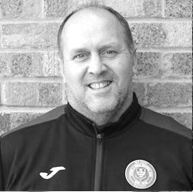
Good afternoon everybody!

Today is a big game for both teams going well in the league, and is an especially big one for us as we have played a few more games than the teams around us.

If we have any hopes of being in the mix at the end of the season you have to beat the good teams around you in the league and our opponents today are looking good so far this season.

Unfortunately today we are missing a few players through suspension but that just gives others a chance to step up to the plate.

On the injury front we still have David Jones (ankle) and Taryn Smith (ankle) still missing for a few more weeks.

On another note we welcome Louis Chin to the club from Chessington & Hook United which I’m delighted about as Louis can play in a number of positions, so that’s a plus for me.

Hopefully we can continue with another good result today and I would like to thank everyone for your continued support.

Simon

Surrey Premier Cup
First Round
Carshalton Athletic U19 | w/o Ash | Ash United
Shene Old Grammarians | 2-4 | Old Wilsonians
Lingfield | 5-1 | Horley Town Reserves
Alfold | 2-0 | Godalming Town
Epsom & Ewell | 5-0 | Knaphill U23
Reigatians | 0-4 | Frimley Green
Met Police Reserves | 3-3 | FC Deportivo Galicia
Met Police Reserves win 5-4 on penalties
Second Round
Ash United | 3-1 | Chessington & Hook United
Alfold | 11/12 | Nottsborough (holders)
Old Wilsonians | 1-6 | Lingfield
Sheerwater | 12/12 | Corinthian Casuals Reserves
Farnham Town | 4-1 | Westfield Reserves
Epsom & Ewell | 4-0 | Dorkinian
Met Police Reserves | V | Dorking Wanderers Reserves
Bagshot | 19/12 | Frimley Green

Esoteric League Division One Challenge Cup
First Round
Farnham Town | 0-1 | Godalming Town
Cove | 2-1 | British Airways
FC Deportivo Galicia | 2-1 | AC London
Second Round
Eversley & California | 2-3 | Bedfont & Feltham
Epsom & Ewell | 1-0 | Sandhurst Town
Tooting Bec | 4-1 | Ash United
Kensington Borough | 0-2 | FC Deportivo Galicia
Sheerwater | 2-3 | Chessington & Hook United
Fleet Spurs | 0-0 - 4-3p | Cove
Dorking Wanderers | 1-2 | Frimley Green
Godalming Town | 6-0 | Bagshot
Quarter-Finals
Tooting Bec | 22/1 | Frimley Green
Bedfont & Feltham | 22/1 prov | Epsom & Ewell
FC Deportivo Galicia | 22/1 | Godalming Town
Fleet Spurs | 2/3 | Chessington & Hook United

Recent Results and Fixtures
Combined Counties League – Saturday 1st December
Ash United | 2-3 | Sandhurst Town
Bagshot | 3-0 | British Airways
Chessington & Hook United | p-p | Farnham Town
Epsom & Ewell | 3-2 | Godalming Town
FC Deportivo Galicia | 1-2 | Frimley Green
Fleet Spurs | p-p | Cove
Kensington Borough | p-p | Eversley & California
Tooting Bec | p-p | Sheerwater
Combined Counties League – Tuesday 4th December
Dorking Wanderers Reserves | 6-2 | Fleet Spurs
Combined Counties League – Saturday 8th December
British Airways | V | Kensington Borough
Dorking Wanderers Reserves | V | Tooting Bec
Epsom & Ewell | V | Bedfont & Feltham
Recent Results and Fixtures
Combined Counties League – Saturday 8th December
Eversley & California | V | Ash United
FC Deportivo Galicia | V | Chessington & Hook United
Frimley Green | V | Fleet Spurs
Godalming Town | V | Sandhurst Town
Sheerwater | V | Bagshot
Combined Counties League – Tuesday 11th December
Cove | V | Bagshot
Fleet Spurs | V | Godalming Town
Combined Counties League – Saturday 15th December
Ash United | V | Godalming Town
Bagshot | V | Fleet Spurs
Bedfont & Feltham | V | Eversley & California
Chessington & Hook United | V | Dorking Wanderers Reserves
Farnham Town | V | Cove
Kensington Borough | V | Sheerwater
Sandhurst Town | V | British Airways
Tooting Bec | V | FC Deportivo Galicia
Combined Counties League – Saturday 22nd December
Bagshot | V | Tooting Bec
British Airways | V | Chessington & Hook United
Cove | V | Frimley Green
Dorking Wanderers Reserves | V | Godalming Town
Eversley & California | V | Sandhurst Town
FC Deportivo Galicia | V | Bedfont & Feltham
Fleet Spurs | V | Ash United
Sheerwater | V | Epsom & Ewell
Combined Counties League – Saturday 29th December
Ash United | V | Farnham Town
Epsom & Ewell | V | Eversley & California
Kensington Borough | V | Dorking Wanderers Reserves
Sandhurst Town | V | Cove
Sheerwater | V | Chessington & Hook United
Combined Counties League – Saturday 5th January 2019
Cove | V | Epsom & Ewell

From behind the goal
Epsom & Ewell 3-0 Dorking Wanderers Reserves
Combined Counties League - Division One - Tuesday 27th November 2018

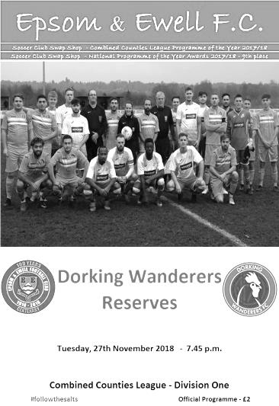
Important win as Chipstead "sponge" impresses again!

There were not many matches scheduled on Tuesday evening and fewer still actually played as a result of the afternoon's torrential rain, yet the High Road pitch remained in excellent condition. Like Peter Kay's description of the Hobnob biscuit in a dunking competition, this incredible piece of turf just keeps on dealing with the wet stuff without appearing to need a break and still looked great at the conclusion of the match!

Or players then matched this with a superb performance, thoroughly warranting the decision to play the match by the referee, although it has to be said that this was one of the few decisions he got right on the night, as a bemusing display, filled with many lectures, followed by a flurry of cards midway through the second half left both sets of players perplexed and our team facing another suspension.

Dorking Wanderers Reserves defeated us 5-3 back in September and contained many former Salts in their starting lineup in Ben Dyson, Louis O'Brien and Rory Sellick, not to mention former Management Team members Jordan Clark and Peter Augustine. They had come off a 5-1 win over Ash United three days previously and were looking for a League double over us. For our part we were looking to bounce back after a flat display at Eversley & California and you might have expected the opposition to have started the better of the teams, especially given our recent habit of slow starts.

However, we changed things up a little ourselves and the return of Jamie Watts to the line-up enabled us to push Lloyd Connelly up front, while Rob Hendry moved to the left in place of the absent Liam Roberts. Additionally Luke Elgar came in for Sam Morgan and had quite an eventful evening! Finally, Reisse Griffin came back into the eleven which moved Adam Heagney back into a holding midfield role after his cameo at left back against Eversley, with Ryan Sullivan playing in a more advanced role at the expense of Elliott Thompson who would enter the fray later. I thought Sullivan had an excellent performance and his regular runs alongside skipper Scott Murphy enabled us to set a much quicker tempo after Saturday's performance and as a result we found it easier to get the ball forwards than we had done in that match.

Sullivan showed as early as the second minute, setting up a move on the right which eventually found its way to Hendry at the far post who saw his shot well tipped over by Drew Churchill in the Dorking goal. Elgar struck over the bar from distance two minutes later, before Hendry forced another decent save with a stinging shot from fifteen yards that Churchill parried away to safety.

In response the visitors were able to fire a shot into our side netting on the quarter hour but were subdued by our overall work rate and pressure and created little in this opening period. Hendry then sent a curling cross straight across the penalty area which Murphy retrieved and crossed for Griffin to send a downwards header goalwards, but Churchill dealt with the bounce and made the save.

There was an unsavoury incident just before the half hour when Sellick went into a challenge and appeared to kick out. Certainly Murphy felt that there was intent and his reaction earned him a yellow card, while many felt Sellick was fortunate to get away with just a yellow. A second booking followed for Mo Amghar after going through Bobby Bennett a few minutes later as the Dorking side were finding this

tactic the only way to slow us down at this stage of the game. Eventually the football took over again and we went ahead in the 35th minute. A delivery from the right was challenged for by Churchill and his defenders but the ball fell straight to the feet of Elgar just four yards out. His shot was well stopped on the goal line by Teddy Ralph but his teammates didn't clear the ball well enough and it was fed back into Bennett on the right to strike the ball across Churchill low into the far corner from eight yards.

It was a deserved goal and following two lectures for Ralph after taking out Hendry twice our striker gained revenge by extending the lead in first half injury time. In truth it should have been Connelly that scored as Churchill slipped when taking a goal kick and he was first to the loose ball, running in on goal, but he didn't get his shot away and was tackled by the keeper. However, as with the first goal the danger wasn't cleared and Bennett delivered a beauty from the right wing that Hendry volleyed into the net at the far post. Two-nil was a fair scoreline as the teams walked off for the interval.

The visitors clearly had a frank discussion at half time and came out in a more attacking mode, although it wouldn't last long. Conor Young tipped a long range effort from substitute Andrew Murphy just over the bar before they had their best chance of the night in the 56th minute when an effort on goal deflected into the path of a striker, although his shot was at Young from ten yards and he made the save.

We settled back into our stride again and Griffin's good run drew defenders, enabling him to set up Connelly, who saw his shot from the edge of the box well blocked by Churchill's legs and from the subsequent corner by Heagney, Elgar met the ball just two feet out but at a very narrow angle and was only able to head the ball onto the post. Just one minute later he then hit the bar with a thumping header from a corner delivered from the other flank. On another day he could have had a hat trick!

The game was still being stopped a bit too often though for some naughty fouls and in the 63rd minute Ralph finally found himself in the book with Sellick then appearing to say something at the time and then picking up a second yellow card for his efforts. Within two minutes, both Dyson and Luke Cunningham had also earned cards for fouls as the referee's patience ran out.

With the visitors resistance wavering Griffin nearly dipped a long range effort just under Churchill's bar before Heagney's corner in the 72nd minute was met by a downward header that bounced up into the net from Jamie Watts around six yards out to provide us with a third goal and record his first goal for the club and now it appeared just a matter of how many we would score. Heagney sliced a shot wide from the edge of the area while two further shots required attempts at saves from Churchill. The first from Hendry was really a goal kick but the referee awarded a corner, while a few minutes later when he did get a touch to the ball, a goal kick was awarded. In the end we had to settle for just the three goals.

This was our fifth straight win at home on a Tuesday night without conceding, and although admittedly, this match was the first league encounter in that sequence, it is still an impressive run. Pity we have no more midweek matches planned, although there will surely be one against this Saturday's opponents Godalming Town when the Cup fixtures are announced.

Overall, whilst we could have had more goals on the night, this was the sort of dominant performance that I hoped we'd see more of this season. We do have the players to win this league and showed what we can do when we are on form, but it's how we negotiate those matches when we are not on form that are the issue right now. If we can find a way to deal with those situations, then it is not too late yet to make a run, although it should be noted that we have now played over half of our 34 league fixtures, so the margin for further error is virtually nil.

Epsom and Ewell: Conor Young, Luke Elgar, Reisse Griffin, Adam Heagney, Jamie Watts, Steve Betancourt, Bobby Bennett, Scott Murphy (c), Lloyd Connelly, Ryan Sullivan,
Rob Hendry

Subs: Elliott Thompson for Sullivan (67), Olly Martinez for Bennett (76),
Todd Murphy for Betancourt (80)

From behind the goal
Epsom & Ewell 3-2 Godalming Town
Combined Counties League - Division One - Saturday 1st December 2018

Salts fight back to win in controversial circumstances

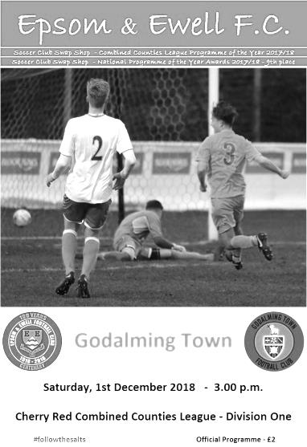
On another very wet day at Chipstead the pitch was again in perfect condition as we welcomed Godalming Town to High Road. The day didn't start well as Simon Funnell was hit by a couple of late notice absentees and this left us with just three men on the bench as a result. In fairness though, the visitors, led by former Epsom keeper Les Cleeveley only had two substitutes of their own!

We opened up brightly for a minute or two and Scott Murphy was not far away with a free kick that was awarded for an early foul on Liam Roberts, but then got off to one of the worst starts we have had in recent months, conceding twice in the opening five minutes of the match. The first goal in the fourth minute came from a deep crossfield ball that was met by the chest of a striker, which Ollie Stevens was first to and finished extremely well with a first time strike past Conor Young from just inside the penalty area. Further disaster followed when a poor defensive pass was intercepted by Jordan Bird and his shot got past Young and we were two-nil down!

Awful though the start might have been, we had showed signs of threat ourselves and I felt there was still plenty of time to turn this around. Reisse Griffin came ever so close to reducing the arrears in the eighth minute when he made a good run, collected a return pass and then curled a right footed shot that deceived Jordan Knight in the visitors goal as he watched the ball go past him, then rebound back past him again as it came back of the face of the post!

Roberts saw his goalbound shot blocked as we began to build some pressure, but the visitors also carried a threat and had a shot deflected wide before having a third goal chalked off for offside. This would have replicated their 3-0 win that they achieved last season, but fortunately for us was not to be. We responded well and Olly Martinez made a good run and cross that Bobby Bennett retrieved and ran in on goal from the wing, but his pull back was blocked for a corner, from which Lloyd Connelly's low shot was well blocked by Bird.

We were back in the match in the 40th minute after Roberts attacked on the left. He got in front of Ashley Wright who then brought him down inside the six yard area, earning a booking for his efforts. Bennett slotted away the penalty; his eighth of the season and a club record equalling ninth for the season already as Murphy has one too. As the half

concluded, Griffin's low effort from twenty-five yards was well saved by Knight before Godalming had a late chance which Young gathered at the second attempt.

We started the second half well as Martinez made a good run to set up Bennett, whose shot was deflected for a corner, and from the corner the ball was fed back out to the right and a low ball in was touched home by Bennett from close range to level the scores at 2-2 in the 47th minute. Pressure continued and Ryan Sullivan made a good run at goal, striking powerfully across Knight, or at least, that was the plan as the ball deflected wickedly off a defender and Knight made a superb save to change direction from left to right and tip the ball away for a corner.

With the match evenly balanced at 2-2 the events of the 63rd minute will be remembered for quite a while. From a deep Epsom corner on the far side of the ground, Murphy collected the ball at the far post, cut back onto his right foot and hit a powerful shot that Knight at first appeared to touch onto the post with the ball coming out and being cleared, but what soon became apparent was that the ball had actually been tipped on to a diagonally placed metal stanchion situated inside the goal! Clearly the Assistant had seen it but maybe was confused because we had all seen the ball come back into play. Anyway, our bench questioned the decision with the Assistant, who then raised his flag; some thirty seconds after the incident had taken place. A discussion ensued with the referee and the goal was given!

It was a strange set of circumstances and if I'm honest really should have been either seen by the referee immediately, or the Assistant should have flagged at the time it happened, but to that point the officials displays had been very good and in their defence you just don't expect to see a ball come away from the goal, unless it has hit the post and stayed out, so I can see how the mistake was made. Looking back, the design of the goal itself didn't help, but in nearly forty years watching Epsom & Ewell I can't recall anything like this happening before!

Understandably the visitors didn't take it very well, even though they knew the ball had gone in. Maybe they thought they had got away with it! Either way, at 3-2 down after leading for so long, they raised their efforts a little and we did well to block a free kick for a corner. We nearly scored a fourth goal in equally rare circumstances when a long Young goal kick took a really solid bounce on the turf and Knight just managed to get a hand to the ball to divert it for a corner. A couple of set pieces for Godalming came to nothing, while both teams then had players dismissed for second yellow card offences; Steve Betancourt for what appeared to be a clash of knees between players in the 86th minute and three minutes later their Captain Bird followed for a second foul.

It was an unfortunate ending to a pulsating match and we now sit in third place as a result of the win. However, we will have to play better than we did today and a better start would help too!

Epsom and Ewell: Conor Young, Todd Murphy, Reisse Griffin, Adam Heagney,
Steve Betancourt, Lloyd Connelly, Liam Roberts, Scott Murphy (c), Bobby Bennett, Ryan Sullivan, Olly Martinez

Subs: Elliott Thompson for T.Murphy (52)

This Day in History - 8th December
Date | Day | Competition |  | Opponents |  | Scorers
08/12/28 | Sat | Friendly | A | Egham | 4-1 | J.Parr, T.Hill, W.Challis (2)
08/12/45 | Sat | London Senior Cup 2 | A | Walton & Hersham | 1-9 | G.Brogdale
08/12/51 | Sat | Surrey Senior Cup 3q replay | A | Surbiton Town | 4-3 | T.Wright (2), B.Goddard (2)
08/12/56 | Sat | Corinthian League | A | Worthing | 1-0 | J.Bangs
08/12/62 | Sat | Corinthian League | H | Eastbourne | 1-3 | E.Arnall
08/12/73 | Sat | Surrey Senior League | A | BAC Weybridge | 2-0 | T.Tuite, D.Ritman
08/12/79 | Sat | London Senior Cup 3q | H | Haringey Borough | 2-1 | F.Samoth, J.Hunn
08/12/84 | Sat | Isthmian League Premier Division | A | Hendon | 2-1 | S.Milton (pen), S.Hill
08/12/87 | Tue | Isthmian League 2s | A | Egham Town | 1-2 | B.Perkins
08/12/90 | Sat | Isthmian League 2s | A | Southall | 1-1 | S.Barwick
08/12/98 | Tue | Isthmian League 3 | H | Ware | 1-2 | S.Grant
08/12/01 | Sat | Isthmian League 3 | A | Wingate & Finchley | 2-0 | S.Huckle, B.Stevens
08/12/09 | Tue | Surrey Senior Cup 2 | H | Chertsey Town | 3-0 | M.Jarman, K.Hough (pen), R.Burns
08/12/12 | Sat | Combined Counties Premier Division | A | Hartley Wintney | 4-0 | R.Burns (3), B.Hayward
Historical Decades
Date | Day | Competition |  | Opponents |  | Scorers
90 years ago – Epsom Town F.C.
08/12/28 | Sat | Friendly | A | Egham | 4-1 | J.Parr, T.Hill, W.Challis (2)
80 years ago – Epsom F.C.
10/12/38 | Sat | London League Cup SF | H | Grays Athletic | 5-1 | F.Stenning (3), J.Jones, A.Curtis
70 years ago – Epsom F.C.
11/12/48 | Sat | London League | A | Chingford Town Reserves | 0-2 | Played at West Street
60 years ago – Epsom F.C.
06/12/58 | Sat | Corinthian League | A | Edgware Town | 2-2 | T.Higgins, T.Millard
50 years ago – Epsom & Ewell F.C.
07/12/68 | Sat | Athenian League 2 | A | Rainham Town | 3-3 | K.Jolly, T.Seymour, D.Legrice
40 years ago – Epsom & Ewell F.C.
09/12/78 | Sat | London Senior Cup 3q | H | Welling United | 1-2 | G.Archer
30 years ago – Epsom & Ewell F.C.
07/12/88 | Wed | London Senior Cup 1 | A | Woodford Town | 1-2 | C.Walcott
20 years ago – Epsom & Ewell F.C.
08/12/98 | Tue | Isthmian League 3 | H | Ware | 1-2 | S.Grant
10 years ago – Epsom & Ewell F.C.
09/12/08 | Tue | Surrey Senior Cup 2 | A | Sutton United | 3-2 | K.Hough, D.Marvell (2)

History Corner – 8th December
80 years ago this week we played Grays Athletic in a London League Cup Semi-Final. However, this was not an ordinary Semi-Final as it was in fact the previous year’s competition, which had been held over! On this occasion we defeated our rivals comprehensively with a hat trick from Fred Stenning helping us to a 5-1 win and a place in the Final against Walton on Thames who would defeat us 2-0 on the Easter Monday at the now sadly flattened Stompond Lane.

73 years ago today and again at Stompond Lane we suffered one of our worst ever defeats by nine goals to one in the London Senior Cup. Gordon Brogdale scored our goal against a very strong team that would have much success in the few years that followed.

70 years ago this week we hosted the newly formed Chingford Town Reserves in a London League match. Their first team had recently joined the Southern League as a new Professional team but were having massive trouble with their pitch and this match had to be switched to our ground even though it was their home match. You wouldn’t have known it as they won 2-0 anyway, although we did get a measure of revenge with a 5-0 win in the return fixture, also at West Street.

40 years ago this week we lost 2-1 at home to Welling United in the London Senior Cup. They were a London Spartan League team back then and we would in fact defeat them a couple of years later in the same competition, but this match eluded us. In their ranks was a local lad by the name of Andy Townsend who would have much success at Chelsea and Aston Villa and with the Republic of Ireland team under Jack Charlton, someone who was equally as Irish!

30 years ago this week we made our first visit to Snakes Lane since the fifties. It was a bizarre evening as the club house was also a night club in full swing! We never really got going in this match and lost 2-1. Tough times were ahead for the club though and they had to vacate the ground. Nowadays it remains as an open space but a new Woodford Town have reformed and it isn’t beyond the realms of possibility that we might see them return close to that site, if not on the exact footprint.

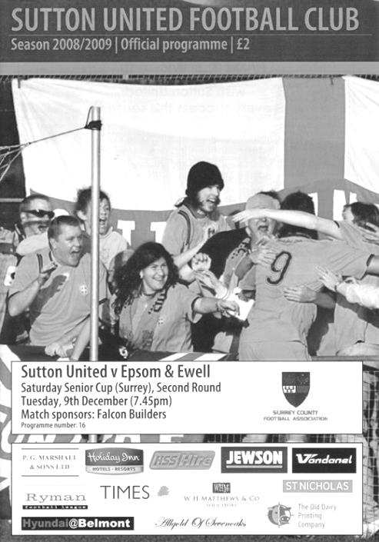
10 years ago this week we travelled to Gander Green Lane, more in hope than expectation for a Surrey Senior Cup tie, having not won there since 1933. Even when Kyle Hough put us ahead with a wonderful looping strike from a narrow angle it was hard to get too carried away and sure enough they equalised before the break, going ahead early in the second half. But they didn’t finish us off and Dale Marvell broke away to score an equaliser in the last ten minutes, then doing exactly the same to score a carbon copy goal to put us ahead with four minutes remaining and this proved to be the winner! (see programme pictured).

6 years ago today we were playing an entertaining goalless draw with Hartley Wintney when substitute Robbie Burns entered the fray and became the first player in club history to score a hat trick as a sub as we won 4-0! Recently of course Taryn Smith has equalled this feat.

First Eleven Appearances 2018/19 - (max 27)
Name | Debut | 2018/19 |  |  |  | Career Totals
 |  | App | Sub | Tot | Goals | App | Sub | Tot | Goals
BENNETT Bobby | 12/08/2018 | 21 | 0 | 21 | 15 | 21 | 0 | 21 | 15
BETANCOURT Steve | 18/08/2018 | 21 | 1 | 22 | 1 | 21 | 1 | 22 | 1
BORRETT Ricky | 04/08/2018 | 9 | 0 | 9 | 0 | 9 | 0 | 9 | 0
CAMPBELL Kieran* | 29/09/2012 | 7 | 3 | 10 | 2 | 59 | 3 | 62 | 2
CAMPBELL Theo | 28/08/2018 | 2 | 9 | 11 | 1 | 2 | 9 | 11 | 1
CAULCRICK Joshua | 17/02/2018 | 0 | 3 | 3 | 0 | 0 | 4 | 4 | 0
CONNELLY Lloyd | 14/10/2017 | 27 | 0 | 27 | 4 | 57 | 4 | 61 | 6
DOBRAJ Endrit* | 18/11/2017 | 5 | 2 | 7 | 1 | 24 | 6 | 30 | 1
DYSON Ben* | 12/08/2017 | 0 | 1 | 1 | 0 | 28 | 14 | 42 | 2
ELGAR Luke | 04/08/2018 | 7 | 3 | 10 | 1 | 7 | 3 | 10 | 1
ELGAR Scott* | 12/08/2018 | 4 | 9 | 13 | 0 | 4 | 9 | 13 | 0
GAFFNEY Luke * | 16/08/2014 | 2 | 2 | 4 | 0 | 12 | 3 | 15 | 0
GAYLE Roy | 06/11/2018 | 3 | 0 | 3 | 0 | 3 | 0 | 3 | 0
GILL George | 28/08/2018 | 2 | 0 | 2 | 0 | 2 | 0 | 2 | 0
GRIFFIN Reisse | 08/08/2015 | 16 | 0 | 16 | 2 | 120 | 13 | 133 | 10
HEAGNEY Adam | 16/08/2016 | 27 | 0 | 27 | 1 | 94 | 13 | 107 | 3
HENDRY Rob | 08/08/2015 | 11 | 0 | 11 | 8 | 95 | 23 | 118 | 36
JEANNOEL Germaine | 02/12/2017 | 0 | 9 | 9 | 2 | 2 | 16 | 18 | 3
JONES David | 31/08/2018 | 6 | 2 | 8 | 0 | 6 | 2 | 8 | 0
LOFTUS-CHEEK Joe | 06/08/2017 | 0 | 1 | 1 | 0 | 14 | 8 | 22 | 6
MARTINEZ Olly | 29/09/2018 | 7 | 3 | 10 | 2 | 7 | 3 | 10 | 2
MCKAY Alex | 20/12/2008 | 1 | 0 | 1 | 0 | 163 | 39 | 202 | 13
MORGAN Sam | 11/09/2018 | 2 | 4 | 6 | 0 | 2 | 4 | 6 | 0
MURPHY Scott | 20/01/2007 | 24 | 0 | 24 | 3 | 71 | 2 | 73 | 7
MURPHY Todd | 27/11/2018 | 1 | 1 | 2 | 0 | 1 | 1 | 2 | 0
ROBERTS Liam | 12/08/2017 | 19 | 2 | 21 | 10 | 40 | 16 | 56 | 15
SMITH Taryn | 28/10/2017 | 6 | 6 | 12 | 5 | 14 | 10 | 24 | 5
SULLIVAN Ryan | 04/08/2018 | 16 | 1 | 17 | 0 | 16 | 1 | 17 | 0
SUTHERLAND Mitchel | 04/08/2018 | 1 | 1 | 2 | 0 | 1 | 1 | 2 | 0
THOMPSON Elliott | 09/02/2016 | 17 | 3 | 20 | 1 | 27 | 12 | 39 | 2
WATTS Jamie | 03/11/2018 | 5 | 0 | 5 | 1 | 5 | 0 | 5 | 1
WHITE Sean | 02/08/2014 | 9 | 4 | 13 | 4 | 29 | 25 | 54 | 9
WOODCOCK Josh | 22/09/2018 | 1 | 0 | 1 | 0 | 1 | 0 | 1 | 0
WRIGHT Kieran* | 15/09/2018 | 3 | 3 | 6 | 0 | 3 | 3 | 6 | 0
YOUNG Conor | 07/03/2015 | 15 | 0 | 15 | 0 | 48 | 0 | 48 | 0
* - Player has left the club

CCL Division One Club Directory
AC LONDON: Telephone: 0208 660 5491 - Colours: Orange/Black/Black
Ground: Whyteleafe FC - 15 Church Road, Whyteleafe. CR3 0AR

ASH UNITED: Telephone: 01252 344264 - Colours: Green with Red Trim/Green/Green
Ground: Shawfields Stadium, Youngs Drive, Shawfields Road, Ash, Aldershot. GU12 6RE

BAGSHOT: Telephone: 01252 623804 - Colours: Yellow/Black/Black
Ground: Fleet Town FC - Calthorpe Park, Crookham Road, Fleet. GU51 5FA

BEDFONT & FELTHAM: Telephone: 0208-890 7264 - Colours: Yellow/Blue/Blue

Ground: The Orchard, Hatton Road, Bedfont. TW14 9QT

BRITISH AIRWAYS: Telephone: 0208-890 7264 - Colours: Sky Blue/Navy Blue/Navy Blue
Ground: Bedfont & Feltham FC - The Orchard, Hatton Road, Bedfont. TW14 9QT

CHESSINGTON & HOOK UNITED: Telephone: 01372-602263 Colours: All Blue
Ground: Chalky Lane, Chessington. KT9 2NF

COVE: Telephone: 01252 543615 Colours: Yellow/Black/Black
Ground: Oak Farm, Squirrel Lane, Cove GU14 8PB

DORKING WANDERERS RES Telephone: 01306 400151 - Colours: Red & White Stripes/ Blue/ Red
Ground: Meadowbank Stadium, Mill Lane, Dorking. RH4 1DX

EPSOM & EWELL Telephone: 01737-553250 - Colours: Royal Blue & White Hoops/Royal Blue/Royal Blue - Ground: Chipstead FC, High Road, Chipstead. CR5 3SF

EVERSLEY & CALIFORNIA Telephone: 0118 973 2400 - Colours: - White & Royal Blue Hoops /Royal Blue/ Royal Blue - Ground: Fox Lane, off Reading Road, Eversley. RG27 0NS

FARNHAM TOWN Telephone: 01252 715305 - Colours: - Claret & Sky Blue /White/ Claret & Blue
Ground: Memorial Ground, Babbs Mead, West Street, Farnham. GU9 7DY

FC DEPORTIVO GALICIA Telephone: 0208 831 9067 - Colours: Royal Blue/Royal Blue/White
Ground: Bedfont Sports FC - Bedfont Sports Club, Hatton Road, Bedfont. TW14 9JR

FLEET SPURS Telephone: 01252 662810 - Colours: Dark Blue with Red Trim/Dark Blue/Dark Blue
Ground: Kennels Lane Farnborough. GU14 0ST

FRIMLEY GREEN Telephone: 01252 835089 - Colours: All Blue
Ground: Frimley Green Recreation Ground, Frimley Green Road, Frimley. GU16 6JY

GODALMING TOWN Telephone: 01483 417520 - Colours: Yellow/Green/Yellow
Ground: Wey Court, Meadrow, Godalming. GU7 3JE

KENSINGTON BOROUGH Telephone: 01372 360151 - Colours: All Blue
Ground: Leatherhead FC – Fetcham Grove, Guildford Road, Leatherhead. KT22 9AS

SANDHURST TOWN Telephone: 01252 878768 - Colours: Red & Black Stripes/Black/Black
Ground: Bottom Meadow, Sandhurst Memorial Park, Yorktown Road, Sandhurst. GU47 9BJ

SHEERWATER Telephone: 01483 772470 - Colours: Royal Blue & White/Royal Blue/Royal Blue
Ground: Woking FC - Laithwaite Community Stadium, Kingfield, Kingfield Road, Woking. GU22 9AA

TOOTING BEC Telephone: 0208 540 8843 - Colours: Black & White Stripes/White/White & Black
Ground: Raynes Park Vale FC – Prince George’s Playing Fields, Grand Drive, Raynes Park. SW20 9DZ

Centre page for results

Centre page for results

EL Records Premier Challenge Cup
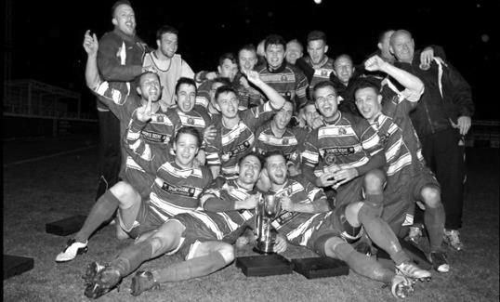
First Round
Camberley Town | 1-3 | Cobham
Horley Town | 0-1 | Chertsey Town
Badshot Lea | 3-1 | Walton & Hersham
FC Deportivo Galicia | 4-1 | Cove
Chessington & Hook United | 2-4 | AFC Hayes
Farnham Town | 1-2 | Southall
Hanworth Villa | 3-1 | Kensington Borough
Second Round
Bedfont & Feltham | 2-0 | Tooting Bec
Sheerwater | 1-0 | Balham
Ash United | 2-3 | Fleet Spurs
Frimley Green | 0-2 | Guildford City
Godalming Town | 2-0 | Dorking Wanderers Reserves
Abbey Rangers | 3-0 | Redhill
FC Deportivo Galicia | 5-0 | AC London
Cobham | 0-3 | AFC Hayes
Abandoned after 88 minutes due to serious player injury - Match awarded to AFC Hayes
CB Hounslow United | 4-1 | Badshot Lea
Hanworth Villa | 2-1 | Sandhurst Town
Epsom & Ewell | 1-0 | Bagshot
Sutton Common Rovers | 4-2 | Southall
Chertsey Town | 3-2 | British Airways
Eversley & California | 1-5 | Knaphill
Banstead Athletic | 4-3 | Colliers Wood United
Spelthorne Sports | 2-1 | Raynes Park Vale
Third Round
FC Deportivo Galicia | 16/1 | Sutton Common Rovers
AFC Hayes | 15/1 | Bedfont & Feltham
Epsom & Ewell | 15/1 | Godalming Town
Sheerwater | 15/1 | Banstead Athletic
Guildford City | 16/1 | CB Hounslow United
Spelthorne Sports | 15/1 | Hanworth Villa
Knaphill | 15/1 | Fleet Spurs
Chertsey Town | 15/1 | Abbey Rangers

Bedfont & Feltham – History
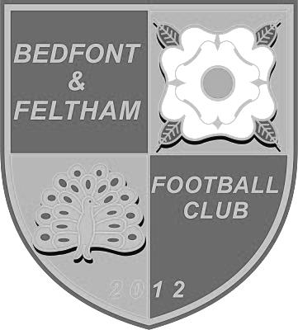
Bedfont & Feltham Football Club was founded in May 2012 following the amalgamation of Feltham FC and Bedfont Football and Social Club, taking Feltham's place in Division One of the Combined Counties Football League.

Feltham had already entered the 2012–13 FA Vase under their own name so the club played as Feltham FC until the start of the 2013–14 season. Two Sunday sides played in the West Middlesex Sunday Football League under the Bedfont & Feltham name; one finishing second in Division One and the other winning Division Two.

The Yellows' first two seasons saw them finish in a respectable fifth place in the Division One table having been early front-runners. They reached the First Round Proper of the FA Vase in 2013-14 and also won the Middlesex Premier Cup.

The club became eligible to compete in the FA Cup for the first time in 2014-15, and reached the First Round Qualifying. The same season also saw the club win the Division One Challenge Cup and become runners-up in the Southern Combination Challenge Cup competition.

For season 2015-16, the club restructured its squad and Youth set-up. The club started strongly and for the second time in its short history made the First Round Qualifying in the FA Cup and the FA Vase competitions. This season saw the Yellows finish as runners-up in Division One, earning promotion to the Premier Division of the Combined Counties Football League. The club also reached the final of the RPM Records Division One Challenge Cup for the

second consecutive season.

The Premier Division experience in 2016-17 started tough with a 2-9 home defeat to Epsom & Ewell on the opening day of the season. This seemed to pave the way for the club’s worst season since its formation: Finishing second from bottom in the Combined Counties Football League’s Premier Division. This resulted in relegation back to Division One.

The club was knocked out of the FA Cup at the first hurdle and of the FA Vase at the second. On a brighter note, they reached the semi-finals of the Southern Combination Challenge Cup and the quarter-finals of the Middlesex FA Senior Charity Cup having unceremoniously exited all other cup competitions in earlier rounds. This prompted the club to appoint Garry Haylock as Manager in late April 2017.

Life back in Division One in season 2017-18 started very poorly and in consequence, Garry Haylock departed in October 2017 to be replaced by Dan Huxley. The poor run experienced in 2016-17 continued, with the club exiting the FA Cup and FA Vase competitions in the opening rounds. The club reached the Quarter-Finals of the Middlesex Premier Cup; Third Round of the Division One Challenge Cup; Second Round of the Middlesex Charity Cup and Second Round of the Southern Combination Challenge Cup.

The squad saw a number of changes throughout the season and found it difficult to bond. This resulted in a bottom four finish. Dan Huxley announced his resignation at the end of the season.

The club quickly appointed former Staines Lammas manager Adam Bessent. He will attempt to arrest the mediocrity that has dogged the club since relegation two seasons ago.

The Club has retained the FA Charter Standard and is now in its sixth season. The current set-up sees a revived Sunday side and Youth teams from Under 7s to Under 10s.

Player Sponsorship
Here is the latest list for 2018/19, with new photos showing all of our players and Management that are available for sponsorship.

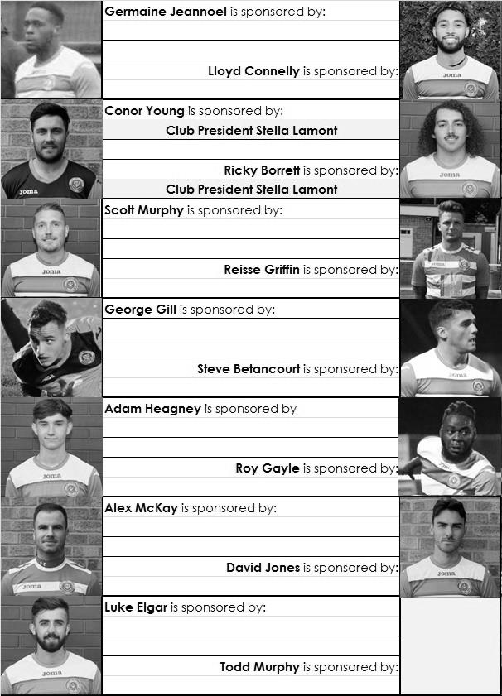

Sponsorship costs just £40 and it is easy to do. Just select a player who has not been previously sponsored and let a Committee Member know that you would like to sponsor them. Beware though. Until we have received the money it is possible for someone to jump in front of you, so don’t delay, sponsor today!
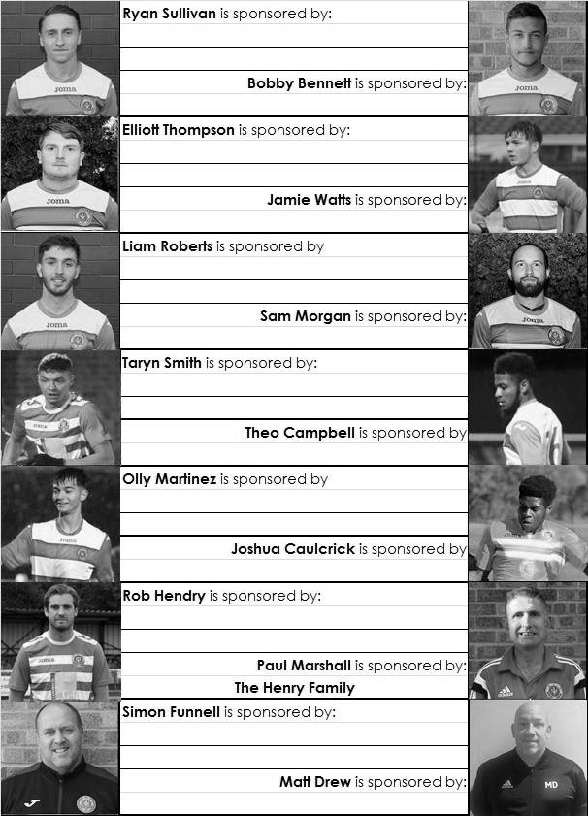

Previous Managers
In our latest instalment we cover the period from 1963 to 1966.

Albert ‘Gil’ Gillings - May 1963 – 23rd March 1965
Bernard ‘Podge’ Willis - 23rd March 1965 – 1st June 1965
Jimmy Smith - 1st June 1965 – September 1966

Following the resignation of Fred Chitty, his recommendation was to promote his Coach Albert ‘Gil’ Gillings to the Manager’s role and the club went with it. (see picture below left)

Gillings was a qualified F.A. Coach, and had been a player with Sutton United in earlier years, but was also listed in the papers as being a Professional player during the War. By being appointed in May 1963 it gave him the full closed season to put a team together. However, on the opening day of the season Uxbridge won 4-0 at West Street and all the optimism faded. The return match against Uxbridge just seven days later hinted at an improvement as we only lost 3-2 at Honeycroft, but it was a disastrous season and for only the second time in history we would finish at the foot of the table. There were some awful defeats, not least 9-0 at Letchworth and 2-9 at Worthing, whilst Letchworth also won the return match at home by seven goals to three after we had been 3-1 up at one stage!

The only results that went our way was a completely surprising win over Slough Town in the F.A. Cup which earned us a decent crowd for the visit of the mighty Walthamstow Avenue, although we lost that match 0-8, and a 7-2 league win over a midtable Wokingham Town side which was good timing as the club met six days later to discuss the following season, at which point Gillings was asked to continue, surely as a result of that recent victory, as we hadn’t secured a single point until defeating Wembley on 7th December!

Clearly it was a mistake to have retained Gillings but with the club in a mess there may not have been many options. We were at least reprieved from relegation in this opening Athenian League season due to a shortage of clubs but the 1964/65 season would prove to be worse still. The club dispensed with all Assistants across the teams in November, and so the departure of Pat Tobin made our Manager’s job harder still.

We rarely produced a result of note except in the cups where we won two ties in both the FA Cup and the Amateur Cup but again didn’t win a point until 14th November and the following week, despite the first goal in the fledgling career of Johnny Eales we somehow let a 5-1 lead turn into a 6-5 defeat at home to Horsham!

Dorking were defeated 5-0 on Boxing Day and it would be they who were our relegation rivals as it became likely

that only one club would go down. We even beat them again by three clear goals in January but followed this with a 5-0 loss at Uxbridge and 8-1 at Tilbury.

With just six matches remaining Gillings chose to resign, quoting work commitments, but it was clear he was jumping before he was pushed. In his place came a caretaker Manager Bernard ‘Podge’ Willis; (pictured left) a former player who had been part of our Corinthian League Memorial Shield winning side in 1960 and had also spent time at Worcester Park. However, he couldn’t halt the slide and it all came down to needing to win our final match at Hertford Town to relegate our Surrey neighbours instead.

This match would go down in history as one of our darkest moments, although it is not exactly clear who made the decisions, but due to the match being on 1st May 1965 the Isthmian League season had ended and so all of their player registrations were deemed completed. We then “borrowed” Eddie Clack, Dave Leonard, John Aldrich, Alf Baldwin and a future Manager in Dave Fillery, all from Tooting & Mitcham United.

Understandably we won the match 4-2 but an official from Dorking had attended the match and stated that Maurice Griffiths had been in the team and was ineligible. It’s true that he had been listed as an ineligible player earlier in the season for us, although we had lost the match in which he played so we were given a warning only, even though he had scored in that match!

What I find so hard to understand is why after bringing in all of these “stars” we would then play the one player who was classed as ineligible and my thoughts are that a picture was produced of him playing in the earlier match and not this one. Either way though, the League found our club guilty and deducted us the two points we had “won”. We were relegated for the first time in our history and by the end of the month Willis had also left the club.

The club advertised the position and Willis was replaced by Jimmy Smith, the former Leyton Orient and Burnley winger on 1st June 1965 on a salary of £5 and 5 shillings per week plus expenses. This surely must have come out of the pockets of the President John Martin as it was a fairly large sum to pay back then. Living in Roehampton he made the fairly short journey over to Epsom and matters did improve on the pitch, but only slightly!

A position of ninth out of 16 was hardly outstanding, especially as we were in the lower Athenian League Division Two by now, but it represented some sort of stability. Or at least it did until he resigned at the end of the season, quoting administrative issues as the main reason for the failure within his four page resignation letter.

Our club had missed the entry deadline for the FA Cup; an error that would result in the resignation of Gordon Temperley at the end of the season, and maybe this helped as Smith was persuaded to stay on for 1966/67 although he then quit again through doctor’s advice in September 1966. Bill Budd became Caretaker for a few weeks before we made a very interesting appointment as our next Manager.

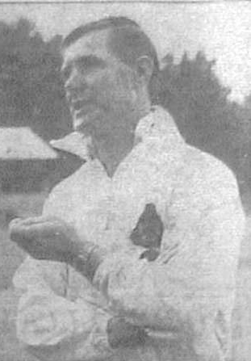

How we stand – Locally and Nationally – inc Sat 01/12/18
Here is the latest update on where we all stand.

To summarise for new readers, there are 28 promotion places currently available at Step Six, with 358 teams battling away for those spots. The Champions of each League are guaranteed a promotion, with the best nine runners-up also going up. This number looks as though it will rise by three due to no likely promotions from the South West Peninsula League and the now confirmed folding of Isthmian League Thamesmead Town, but this could yet increase further. For now we’ll continue to look at the 28 and anything else will be a bonus!

In our previous update, we were listed as 72nd Nationally but since then we have drawn with Kensington Borough and beaten Dorking Wanderers Reserves and Godalming Town, but lost to Eversley & California and now sit in 89th place.

Below is our current League table sorted by points per game, while across the page we have the overall top ten and most importantly the 28 clubs who would go up if the season ended right now.

Frimley Green, currently holding the runners-up spot in our League on points per game hold the 18th best record of the 19 second placed teams. Our league is so competitive right now that it may well prove to be just the Champions that go up, but I’ll keep updating the position here while we remain involved.

Combined Counties League Division One Table – by PPG
 | Pld | W | D | L | Pts | GD | PPG | Pos
Bedfont & Feltham | 15 | 11 | 3 | 1 | 36 | +40 | 2.40 | 2
Frimley Green | 18 | 11 | 5 | 2 | 38 | +12 | 2.11 | 1
Farnham Town | 15 | 9 | 4 | 2 | 31 | +20 | 2.07 | 5
Sheerwater | 16 | 10 | 3 | 3 | 33 | +14 | 2.06 | 4
Epsom & Ewell | 18 | 11 | 1 | 6 | 34 | +14 | 1.89 | 3
Sandhurst Town | 16 | 9 | 3 | 4 | 30 | 0 | 1.88 | 6
Tooting Bec | 16 | 9 | 2 | 5 | 29 | +10 | 1.81 | 7
Chessington & Hook United | 15 | 7 | 2 | 6 | 23 | 0 | 1.53 | 11
Dorking Wanderers Res | 18 | 8 | 3 | 7 | 27 | +3 | 1.50 | 8
Ash United | 17 | 7 | 4 | 6 | 25 | +6 | 1.47 | 9
British Airways | 18 | 7 | 3 | 8 | 24 | -2 | 1.33 | 10
Eversley & California | 14 | 5 | 1 | 8 | 16 | -5 | 1.14 | 13
Bagshot | 18 | 5 | 2 | 11 | 17 | -36 | 0.94 | 12
Godalming Town | 15 | 3 | 3 | 9 | 12 | -14 | 0.80 | 14
Kensington Borough | 16 | 3 | 3 | 10 | 12 | -18 | 0.75 | 15
Fleet Spurs | 15 | 3 | 0 | 12 | 9 | -18 | 0.60 | 17
FC Deportivo Galicia | 16 | 2 | 3 | 11 | 9 | -8 | 0.56 | 16
Cove | 14 | 2 | 1 | 11 | 7 | -18 | 0.50 | 18

Step Six Table – by PPG – Top 10
 | Which League? | Pld | Pts | GD | PPG | Current Pos.
Harefield United | SSML | 16 | 44 | +38 | 2.75 | 1
Lutterworth Town | UCL | 15 | 40 | +53 | 2.67 | 1
Cheltenham Saracens | HellW | 9 | 24 | +26 | 2.67 | 1
Thame Rangers | HellE | 6 | 16 | +11 | 2.67 | 3
Selston | E.Mids | 19 | 50 | +49 | 2.63 | 1
Thornbury Town | HellW | 8 | 21 | +26 | 2.63 | 3
Easington Sports | HellW | 8 | 21 | +19 | 2.63 | 4
Tividale | W.Mids | 21 | 55 | +63 | 2.62 | 1
AFC Stoneham | Wess | 15 | 39 | +47 | 2.60 | 3
Steyning Town | Scomb | 15 | 39 | +25 | 2.60 | 1
Epsom & Ewell | We are 89th | 18 | 34 | +14 | 1.89 | 3

Step Six Table – The 28 Promoted Clubs if the season ended today
The 19 Champions – Based on current PPG
 | Which League? | Pld | Pts | GD | PPG | Current Pos.
Harefield United | SSML | 16 | 44 | +38 | 2.75 | 1
Lutterworth Town | UCL | 15 | 40 | +53 | 2.67 | 1
Cheltenham Saracens | HellW | 9 | 24 | +26 | 2.67 | 1
Thame Rangers | HellE | 6 | 16 | +11 | 2.67 | 3
Selston | E.Mids | 19 | 50 | +49 | 2.63 | 1
Tividale | W.Mids | 21 | 55 | +63 | 2.62 | 1
AFC Stoneham | Wess | 15 | 39 | +47 | 2.60 | 3
Steyning Town | Scomb | 15 | 39 | +25 | 2.60 | 1
Harleston Town | EastN | 19 | 49 | +41 | 2.58 | 1
Billingham Town | Northern | 18 | 46 | +37 | 2.56 | 1
Longridge Town | NWCN | 20 | 50 | +55 | 2.50 | 1
Cheddar | Western | 14 | 35 | +32 | 2.50 | 2
Bedfont & Feltham | CCL | 15 | 36 | +40 | 2.40 | 2
Racing Club Warwick | Midland | 16 | 38 | +36 | 2.38 | 2
Tavistock | SWP | 16 | 38 | +29 | 2.38 | 2
Rylands | NWCS | 17 | 40 | +43 | 2.35 | 2
Welling Town | SCEFL | 17 | 39 | +22 | 2.29 | 1
Hashtag United | EastS | 17 | 39 | +20 | 2.29 | 3
Grimsby Borough | NCEL | 17 | 38 | +38 | 2.24 | 2
The 9 Best Runners-Up
Thornbury Town | HellW | 8 | 21 | +26 | 2.63 | 3
Amesbury Town | Wess | 17 | 44 | +33 | 2.59 | 1
Anstey Nomads | UCL | 15 | 38 | +45 | 2.53 | 2
AFC Varndeanians | Scomb | 15 | 38 | +29 | 2.53 | 2
Newark Flowserve | E.Mids | 19 | 47 | +58 | 2.47 | 2
Winslow United | SSML | 14 | 34 | +36 | 2.43 | 3
Burnham | HellE | 10 | 24 | +17 | 2.40 | 1
Black Country Rangers | W.Mids | 18 | 42 | +38 | 2.33 | 2
Carlisle City | NWCN | 19 | 44 | +20 | 2.32 | 2

Match and Ball Sponsorships – 2018/19
Opponent | Date | Match Sponsor | Ball Sponsor
Chessington & Hook Utd | 21/08/18 | Club President - Stella Lamont
Beckenham Town (FAC) | 28/08/18 | Building Shop Ltd
Cove | 08/09/18 | EEFC Management Committee
Tooting Bec | 15/09/18 | Building Shop Ltd
Bagshot (LC) | 25/09/18
Sheerwater | 06/10/18 | Paul Merritt
Knaphill U23  (Surrey Premier Cup) | 23/10/18 | Jack Jarman
Frimley Green | 03/11/18 | Our Chairman’s Grandchildren – George, Joseph, Ezara and Inaya
Sandhurst Town (LD1C) | 06/11/18 | Richard Lambert
Kensington Borough | 17/11/18 | Jeff & Arnold Pye
Dorkinian (SPC) | 20/11/18
Dorking Wanderers Res | 27/11/18
Godalming Town | 01/12/18 | John Bonner
Bedfont & Feltham | 08/12/18
Eversley & California | 29/12/18
Ash United | 12/01/19
Bagshot | 19/01/19
Farnham Town | 02/02/19
British Airways | 16/02/19
AC London | 02/03/19
FC Deportivo Galicia | 12/03/19
Fleet Spurs | 06/04/19
Sandhurst Town | 20/04/19 | Club President - Stella Lamont
Godalming Town (LC) |  | Date unknown
Unknown (SPC) |  | 3rd Round – might be at home
Match sponsorship costs just £60.00!

Sponsorship includes:

Admission, programmes and hospitality for three people.

A full page advert in the programme and mascot for the day (if required).

If you are interested, just speak to a Committee Member,
or drop me an email at: richard.c.lambert@gmail.com

Combined Counties League Premier Division
Opponents All-time Records
incl Saturday  1st December | P | W | D | L | F | A | PPG | GD | Best  Win | Worst  Loss
Bedfont & Feltham | 2 | 2 | 0 | 0 | 13 | 3 | 3.00 | +10 | 9-2 | -
AC London | 1 | 1 | 0 | 0 | 6 | 0 | 3.00 | +6 | 6-0 | -
Bagshot | 2 | 2 | 0 | 0 | 4 | 0 | 3.00 | +4 | 3-0 | -
FC Deportivo Galicia | 1 | 1 | 0 | 0 | 3 | 0 | 3.00 | +3 | 3-0 | -
Tooting Bec | 1 | 1 | 0 | 0 | 3 | 1 | 3.00 | +2 | 3-1 | -
Fleet Spurs | 1 | 1 | 0 | 0 | 3 | 2 | 3.00 | +1 | 3-2 | -
Frimley Green | 11 | 9 | 1 | 1 | 35 | 5 | 2.55 | +30 | 7-1 | 0-1
Godalming Town | 4 | 3 | 0 | 1 | 7 | 7 | 2.25 | 0 | 3-2 | 0-3
Ash United | 20 | 11 | 3 | 6 | 50 | 32 | 1.80 | +18 | 6-0 | 0-3
Farnham Town | 18 | 9 | 4 | 5 | 31 | 29 | 1.72 | +2 | 3-0 | 1-4
Cove | 35 | 16 | 9 | 10 | 78 | 57 | 1.63 | +21 | 7-0 | 1-6
Chessington & Hook | 30 | 13 | 9 | 8 | 63 | 45 | 1.60 | +18 | 6-0 | 1-3
Sheerwater | 5 | 2 | 2 | 1 | 10 | 5 | 1.60 | +5 | 3-0 | 2-3
Dorking Wanderers Res | 2 | 1 | 0 | 1 | 6 | 5 | 1.50 | +1 | 3-0 | 3-5
Sandhurst Town | 16 | 7 | 0 | 9 | 28 | 28 | 1.31 | 0 | 4-0 | 1-3
Kensington Borough | 1 | 0 | 1 | 0 | 1 | 1 | 1.00 | 0 | - | -
British Airways | 1 | 0 | 0 | 1 | 2 | 3 | 0.00 | -1 | - | 2-3
Eversley & California | 1 | 0 | 0 | 1 | 1 | 2 | 0.00 | -1 | - | 1-2

A new club record!
Our Manager may not have been long in the role but I can report that we have already recorded a club record sequence!

Although the first of the wins, against Bagshot, came under the previous tenure, we have now won our last five midweek home matches without conceding a goal and the last four of these, against Knaphill Under 23s, Sandhurst Town, Dorkinians, and Dorking Wanderers Reserves have all come on Simon Funnell’s watch!

The record for consecutive midweek home wins in currently seven, recorded between September 1938 and December 1946 when of course there were fewer midweek matches. This is the eighth occasion where we have won at least five consecutive midweek home matches but the first without conceding a goal, although a couple of six win sequences in 1981 and 2016 were recorded with the concession of just one goal. Well done chaps, let’s keep the run going on 15th January against Godalming Town!

Combined Counties League – Division One
Saturday, 8th December 2018 - Kick-off 3.00 p.m.
Epsom and Ewell  (Royal Blue & White hoops) | V |  | Bedfont & Feltham  (Red and White / Red / Red )
Squad | NUMBERS |  | Squad
Conor Young |  |  | David Windmill
Ricky Borrett |  |  | Ashley Hitchinson
Luke Elgar |  |  | Billy Nutbeam
Reisse Griffin |  |  | James Wilson
Lloyd Connelly |  |  | Elliott Hayden
Jamie Watts |  |  | Jamie Pearce
Steve Betancourt |  |  | Farhad Mahboudi
David Jones |  |  | Pete Davis
Adam Heagney |  |  | Michael Capon
Todd Murphy |  |  | Ross Nunn ©
Ryan Sullivan |  |  | Jordan Sarfo
Liam Roberts |  |  | Tom Hayden
© Scott Murphy |  |  | Paul Nunn
Scott Elgar |  |  | John Nunn
Elliott Thompson |  |  | Kelvin Karanja
Bobby Bennett |  |  | Reece Gairy
Rob Hendry
Roy Gayle
Olly Martinez
Germaine Jeannoel
Joshua Caulcrick
Taryn Smith
Simon Funnell | MANAGER |  | Adam Bessent
Matt Drew | ASST MANAGER |  | Jake Bessent / John Nunn
Sam Morgan | COACHES
 | PHYSIO |  | Andy Nolan
REFEREE: S.Hart
ASSISTANTS: S.Tyler, R.Redman

OUR NEXT VISITORS TO HIGH ROAD
Eversley & California
Combined Counties League – Division One
Saturday, 29th December 2018 – 3.00 pm

